Chapter 14 Testing Verification –
Github Site Links - https://jocooper317.github.io/SDEV153-WebPage/
https://github.com/jocooper317/SDEV153-WebPage.git

Index.html page
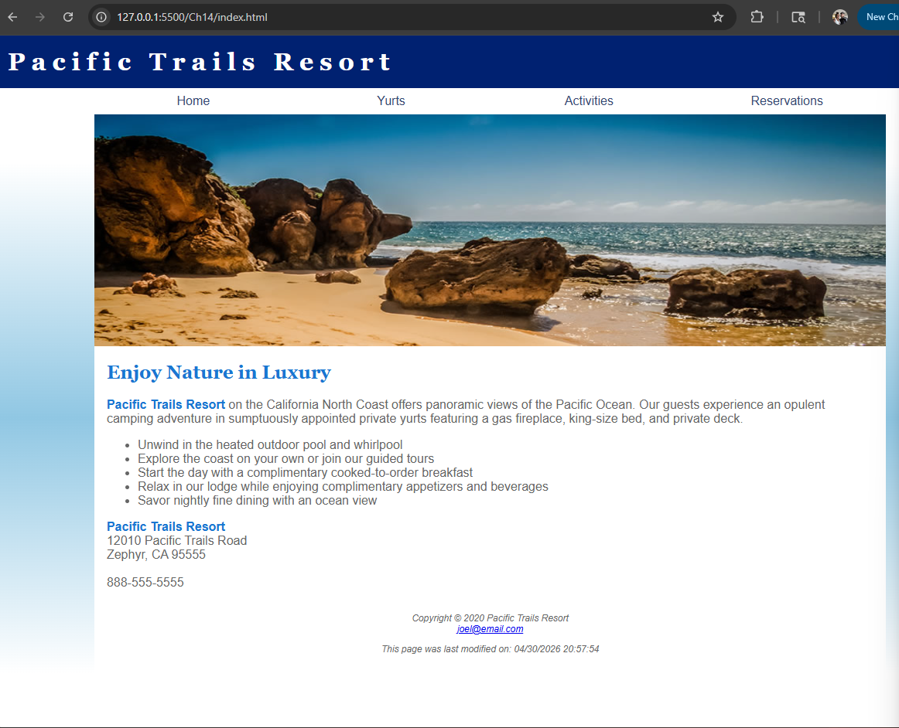

Yurts.html
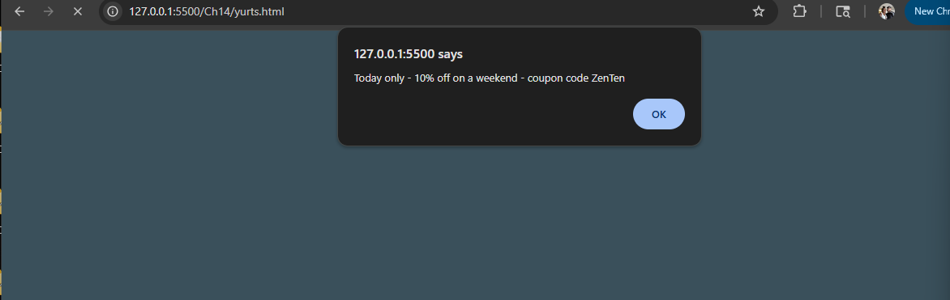
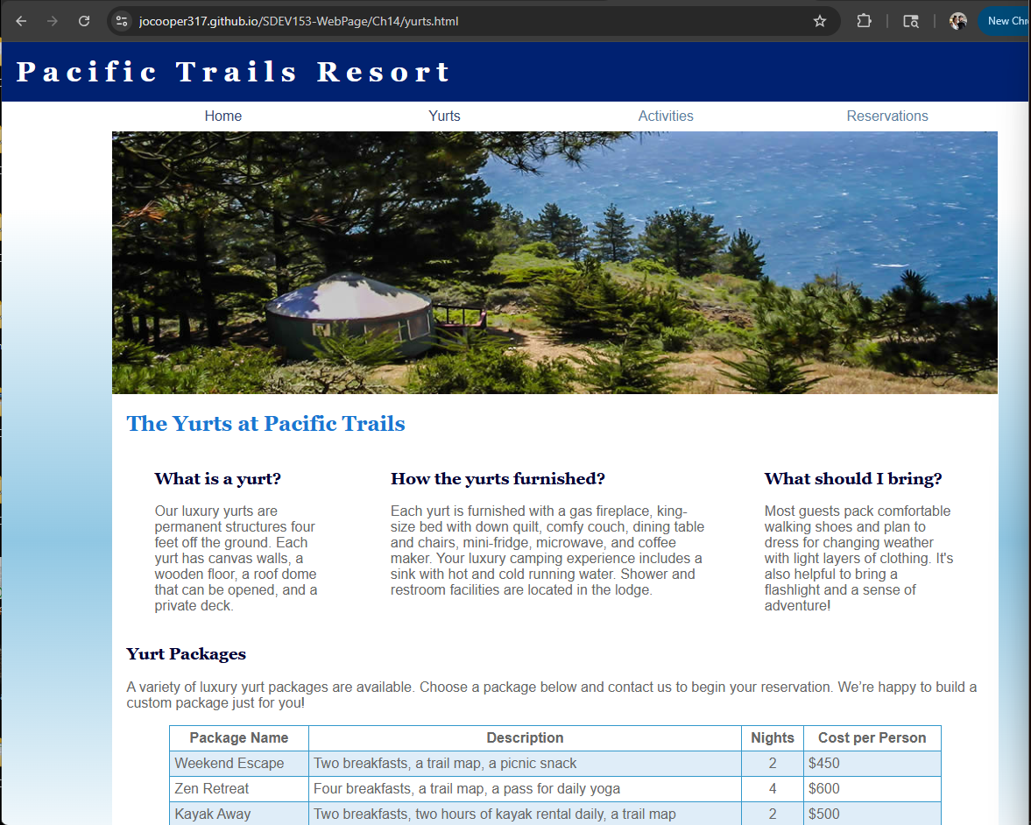

Activities.html
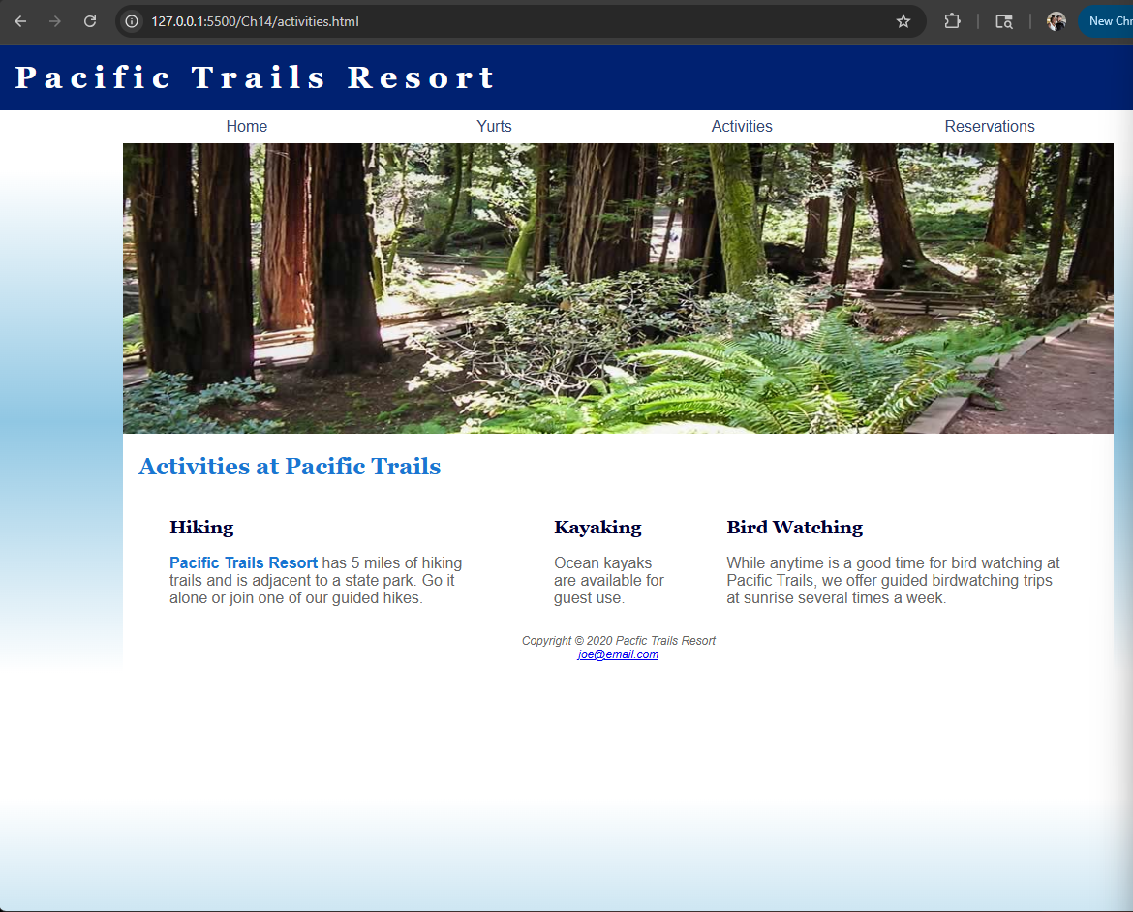

Reservations.html
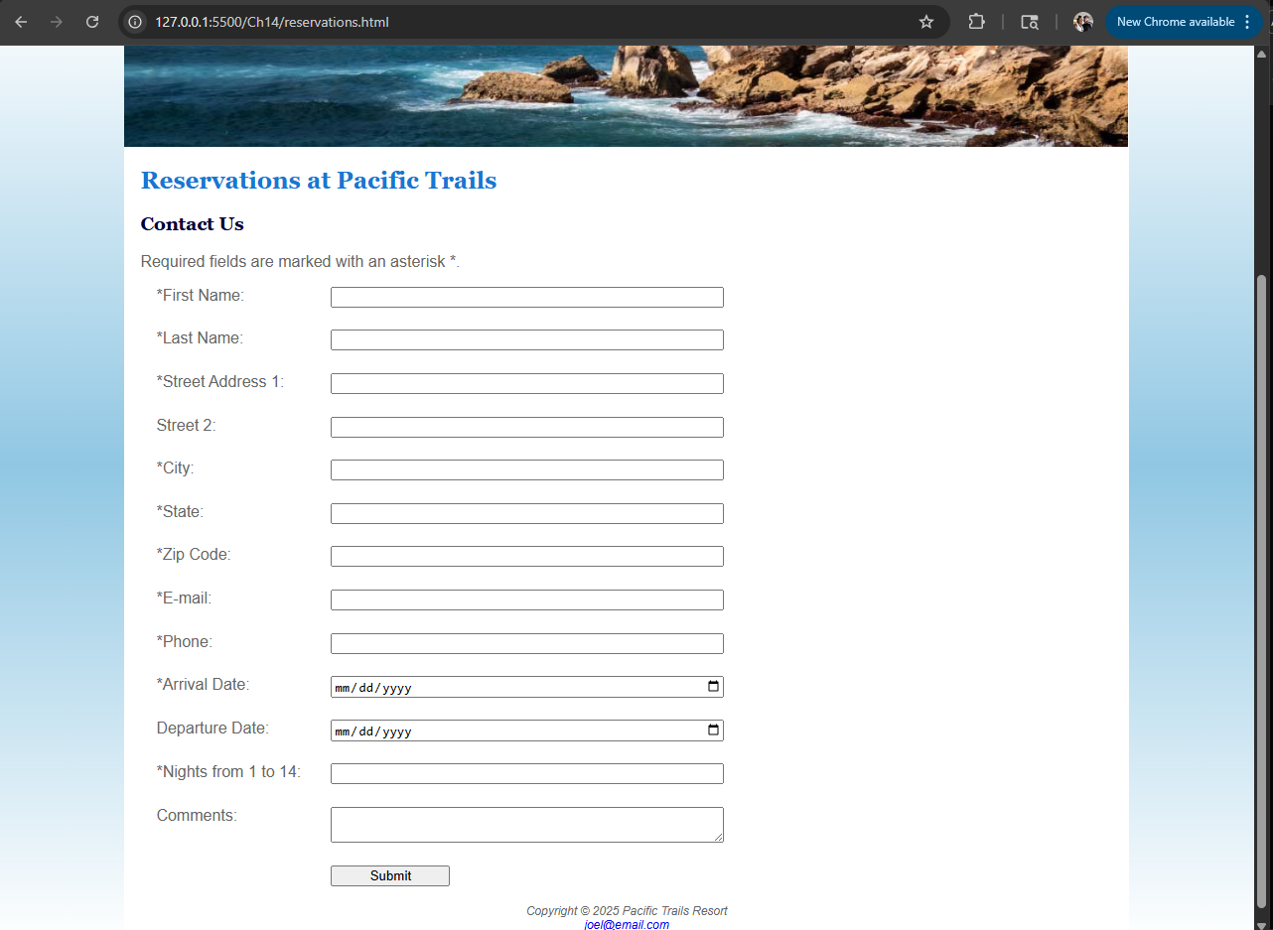
Error phone number format
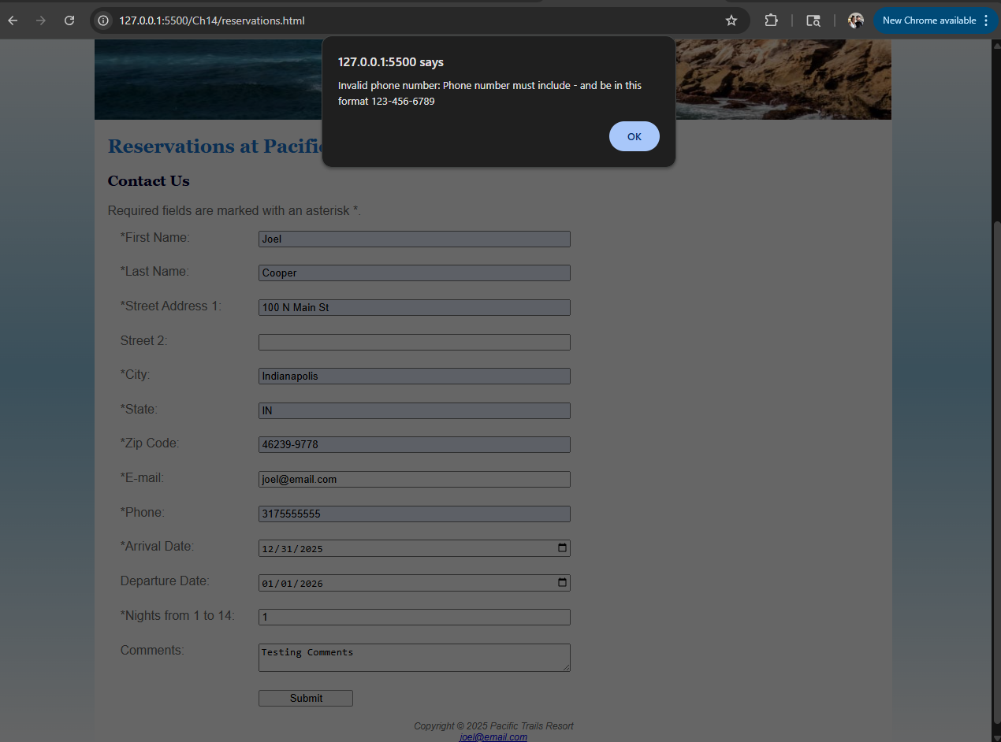

Corrected phone number format
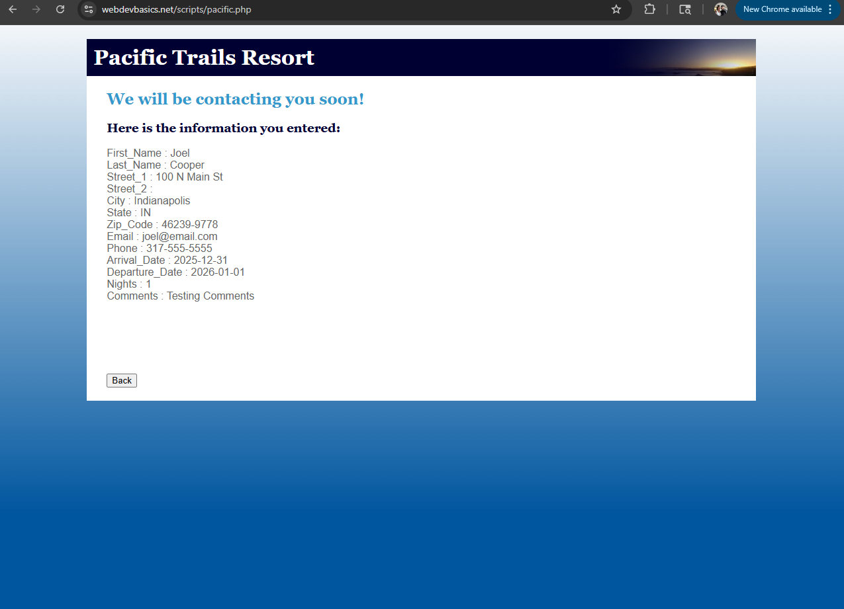

Pacific.css W3C validation
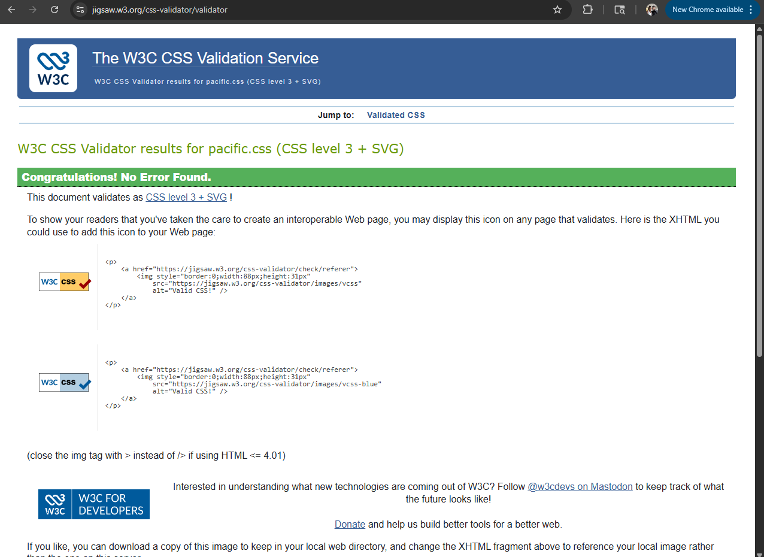

Yurts.html W3C Validation
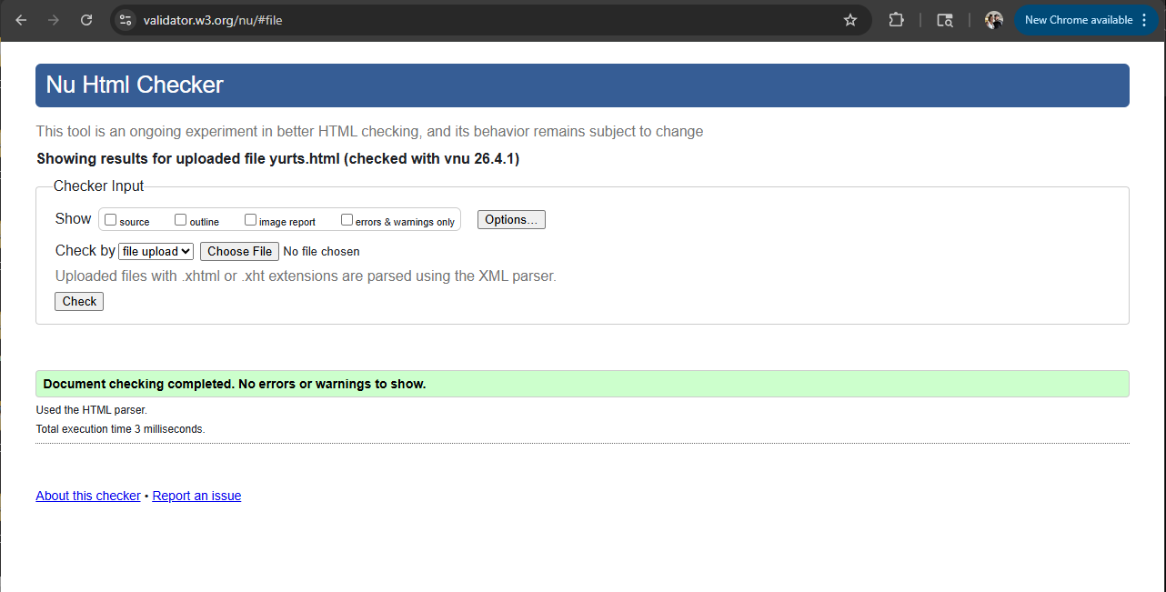
Reservations.html W3C Validation
